OCWR
Free Compost and Mulch Program
INTERNAL
Transaction & Confirmation Flow
OCWR resident places order through Agromin’s online ordering platform using coupon issued by OCWR for use online only. There will be 2 coupon codes per jurisdiction. Agromin receives the order and will respond via email to the customer with instructions for pick up or delivery.
- Addresses are auto-verified during order placement.
  - Should customers have questions regarding coupon codes not working, we will direct them to email sales@agromin.com where Kendall or Emily can respond.
- Orders less than 5 yards will be given instructions to schedule their pickup time/location for self-loading material
- Orders over 5 yards will be given instructions to check in at the respective yard to be loaded by OCWR staff
- Delivery orders will be forwarded to greg@agromin.com to coordinate and confirm hauling.
  - Delivery Request Workbook - all delivery requests will be managed here
- Ofelia will be CC’d on all email communications to ensure accurate coordination of customer pickups and deliveries with each yard.

For Will Call:
- After placing their order, customers will receive email instructions for fulfilling their order.
  - Any orders under 5 yards will be given the following instructions:
    - Email Template UNDER 5 yards
  - Any orders over 5 yards will be given the following instructions:
    - Email Template OVER 5 yards
- Customers will be advised to bring proof of purchase (via email confirmation) and proof of address within the County for order confirmation.
- For Self-Loading, customers will use a QR code to self-submit their order fulfillment
  - 5 gallon buckets will be provided as customer measurement
    - Frank Bowerman QR Code
    - Olinda Alpha QR Code
    - Prima QR Code
- For OCWR loaded customers, drivers will weigh out and OCWR will log fulfillment on the Greenery Logs

For delivery:

  - Greg Jackson, with Agromin, will contact the customer; delivery time will be arranged.
    - Create a hauling schedule workbook to record (insert here)
    - Every Friday, Greg will email Ofelia with next week's delivery schedule
  - The hauler will be given a manifest with the order # and material. This will be signed upon material pick up.
    - Manifest Slip
  - OCWR will log the hauling manifest with the customers sales order on the Greenery Log upon pick up of material.
  - Agromin will monitor the fulfillment of these orders during the monthly reporting upon receipt of OCWR Greenery Logs.

Agromin will endeavor to verify all orders before providing them to OCWR for fulfilment. OCWR will be asking Will Call customers to verify the IDs as best they can. Agromin and OCWR will monitor for abuse and communicate anything we find to decide on the next appropriate action.

EXTERNAL

Information posted to the public:

OCWR Free Compost and Mulch Program
In partnership with Agromin, ordering compost and mulch just got easier.

Free Compost and Mulch is available to residents within Orange County

What is the program?
The program is a partnership with organic waste recycler, Agromin, to provide free compost and mulch to qualified residents within Orange County. The program is a way to give back to the community while meeting regulations required by Senate Bill 1383.
The compost, produced by OCWR, is made from organic material that would otherwise end up in landfills. By participating in this program, you are playing an important role in closing the recycling loop, allowing more room in landfills and reducing greenhouse gas emissions. Plus, you’ll enjoy more vigorous and healthier plants and gardens.

How do I participate?

Residents within Orange County can order compost and/or mulch directly from Agromin with the instructions below.
Coupon Parameters:
Valid April 15, 2026 – December 15, 2026

- Unlimited uses per residence for up to 6 yards Compost per order (bulk material)
- Unlimited uses per residence for up to 15 yards Cover Mulch per order (bulk material)

Bulk Material Pick-Up Instructions (Free)
- Step 1: Visit shop.agromin.com to start your order.
- Step 2: Choose Order in Bulk – Enter Zip Code
- Step 4: Select your material type (Cover Mulch or Compost)
- Step 5: Select your preferred quantity (in yards) and head to "My Cart" to checkout. Note: The minimum order is 0.5 yards and maximum order per coupon use is 6 yards Compost or 15 yards Mulch. Any orders under 5 yards will be self- loading. Any orders over 5 yards will require a truck or trailer to be loaded by OCWR staff.
- Step 6: Create an Account (required to use coupon code)
- Step 7: Enter "billing" info and select pickup.
- Step 8: At final checkout, enter the coupon code corresponding with the City on your residential address. [Insert link to the list of coupons]
- Step 9: Wait for an Email with pick up instructions from an Agromin representative.
- Step 10: Bring your email confirmation AND proof of address within Orange County (I.D. or utility bill) to pick up your material.
Bulk Delivery Instructions (Delivery fees apply)
- Step 1: Visit shop.agromin.com to start your order.
- Step 2: Choose Order in Bulk – Enter Zip Code
- Step 3: Select your material type (Cover Mulch or Compost).
- Step 4: Select your preferred quantity and head to "My Cart" to checkout.
  - Note: The minimum amount for delivery is 3 cubic yards (covers about 150 square feet with a 3-inch depth). The maximum is 6 cubic yards for Compost and 15 cubic yards for Cover Mulch per online order.
- Step 5: Create an account. (required to use coupon code)
- Step 6: Enter "billing" info and select "ship to my address."
- Step 7: At final checkout, enter the coupon code corresponding with the City on your residential address. [Insert link to the list of coupons]
- Step 8: Pay the designated delivery fee.
  - Note: A representative from Agromin will contact you to schedule delivery.

Location Hours of Operation
  - Bee Canyon Greenery | M-Sat 8am - 4pm
  - 11002 Bee Canyon Access Rd.
  - Irvine, CA 92602
  - (949) 551-7100

  - Capistrano Greenery | M-Sat 8am - 4pm
  - 32250 Avenida La Pata
  - San Juan Capistrano, CA 92675
  - (949) 728-3040

  - Valencia Greenery | M-Sat 7am - 3pm
  - 1942 N. Valencia Ave
  - Brea, CA 92823
  - (714) 993-7396

For ALL Orders, Please Note:
- Once your order is placed, you will receive email instructions on how to collect your material.
- Orders placed outside of business hours will be responded to by our sales team the next business day.
- You must have proof of purchase to collect your order.

FAQs
For the self-loading area, how much material will fit in a 5 gallon bucket?
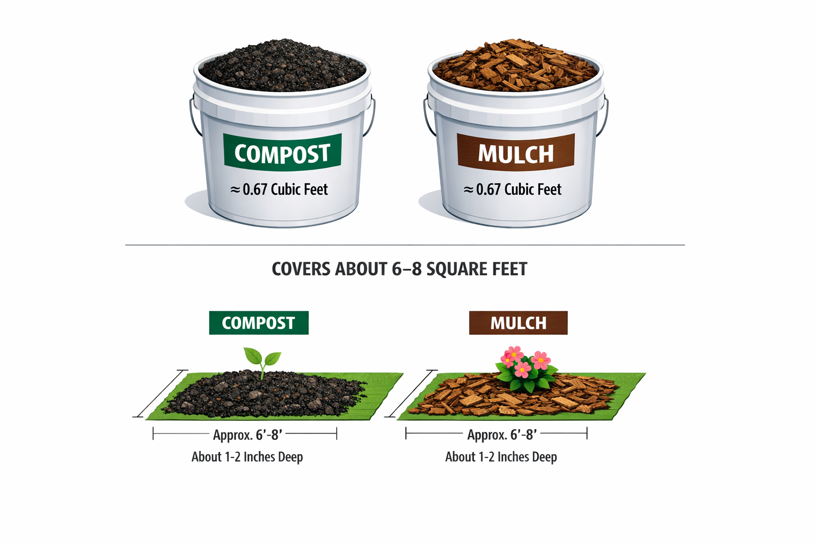
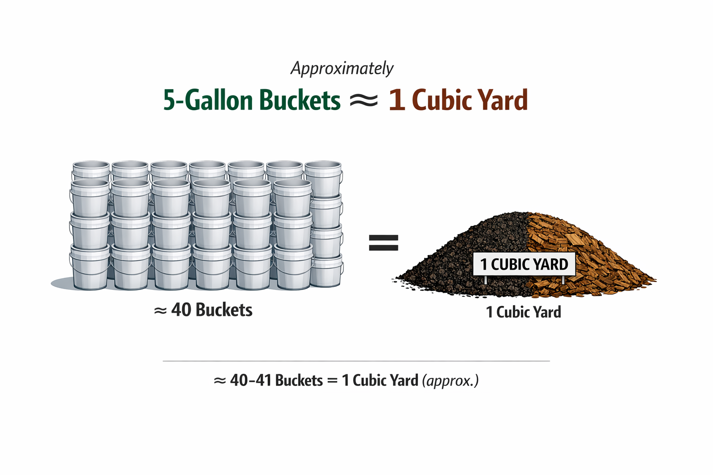

How much product is 15 cubic yards?
1 cubic yard equals about 1 standard truck bed. 15 cubic yards will fill about 1 bobtail truck.
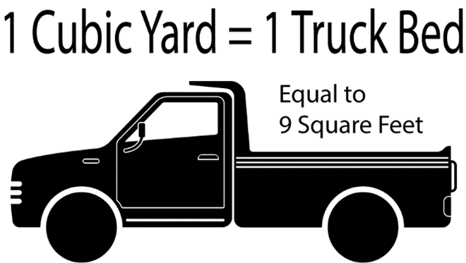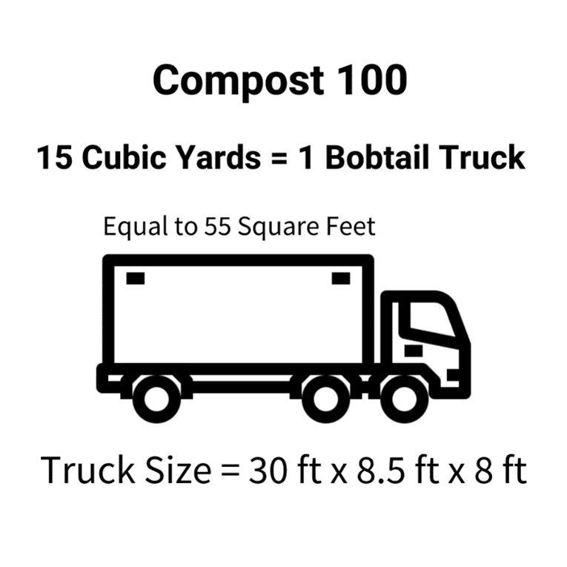

What kind of vehicle should I bring to pick-up at the yard?
Trucks or trailers only. Staff will help load your truck or trailer using heavy equipment. (Cars will not be loaded)

Are these products organic?
Yes, Compost 100 is OMRI listed and certified as organic.
If you have questions about the Free Compost Program, contact sales@agromin.com
Learn How Compost Can Help Your Vegetable Garden Thrive

